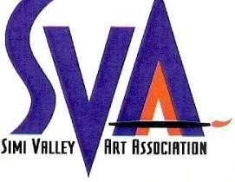
SIMI VALLEY ART ASSOCIATION

Membership Form

Regular Membership Annual Dues: $40 Individual or $60 Family
$20 College / Full Time Students (min age 18)

Information about the time and place of our General Meetings, Special Events, etc. will be in our newsletters and emailing.

Name: _________________________________________________________________ Birthdate: __________________
Month/Year

Mailing Address: _____________________________________________________________________________________

Phone: _______________________________ Email: ______________________________________________________

Art Medium/s: _______________________________________________________________________________________

SVAA is a volunteer non-profit association and requires the help and support of all its members.
Please select below where you can help.

VOLUNTEER PREFERENCES
- Annual Member’s / People’s Choice Show
Artwork take in & pick up, hanging, grids setup & take down
- Annual Open Juried Show
Artwork take in & pick up, hanging, labeling, show brochures, grids setup & take down
- Newsletter
http://www.simivalleyart.org/svaa-newsletter.html
- Publicity / Advertising
Local newspapers
- Simi Valley Library Art Display
http://www.simivalleyart.org/library-display.html
- Website / Social Media
http://www.simivalleyart.org/, Facebook, Instagram
- Hospitality / Receptions
Setup table, chairs, food & clean up.

ADMINISTRATION / BOARD MEMBERS Forms & Payments by check mail to:
- President Terry Walson
- Vice President c/o SVAA
- Treasurer 5381 Seneca Place
- Recording Secretary Simi Valley, CA 93063

Forms can also be emailed to:

Date: _____________ Amount Paid: ______________ trwalson@hotmail.com
*A completed membership form is required for acceptance into the association.* **Membership dues are nonrefundable** rev 12/22

